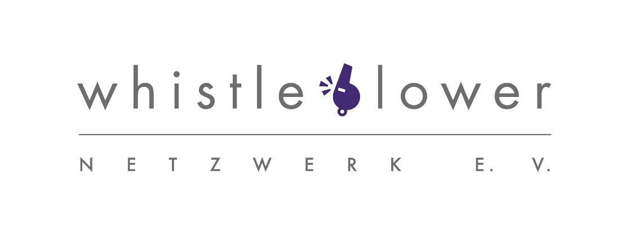

Support Whistleblower-Netzwerk e.V. in its work and become a sponsoring member. Send this form by mail to the following address or by or e-mail to:

Whistleblower-Netzwerk e.V.

c/o DJV

Alte Jakobstr. 79/80

10179 Berlin
E-mail: info@whistleblower-net.de
You will find further information and a donation form here on our Website: https://www.whistleblower-net.de/uber-uns/spenden/

Together, let us make this world a better place, and more just!
Whistleblower-Netzwerk e.V.
Board: Dr. Detlev Böttcher, OstA a.D. Robert Bungart, Annegret Falter (Chairlady), Markwart Faußner, Thomas Holbach
Register of Associations: Berlin (Charlottenburg) VR 37467
E-Mail: info@whistleblower-net.de
Internet: www.whistleblower-net.de

Declaration of sponsoring membership
Family name: My monthly contribution is: ……….. €
First name: (Regular fee 10 € / low-income earners 5 € ) Street/Number:
Post code/Place/(Country):
E-Mail/phone.:

I pay my contribution via (the direct debit mandate involves the least amount of administrative work for us):
  - SEPA Direct Debit Mandate and authorise Whistleblower-Netzwerk e.V. (Creditor -ID: DE25ZZZ00000307494) to debit the above monthly sponsoring membership fee
☐ annually or ☐ semi-annually from my account.

☐ Standing order, which I have set up in the above ☐ semi-annual ☐ ☐ annual amount to the account of

IBAN: DE92 1005 0000 0190 8663 65, BIC: BELADEBEXXX of Whistleblower-Netzwerk e.V.
at Berliner Sparkasse.

Place/Date:……………………………………........

